**Preparation and Maintenance of ZOHO Book Healthhub Medical clinic**

**Project Team members: JAMES LENI.A**

**1. INTRODUCTION**

**1.1 Overview:**

This project is deal with Healthhub medical clinic, a Health care uses ZOHO Books to effectively manage their financial processes, maintain accurate records, and make informed financial decisions. This integration enhances their overall business efficiency and contributes to their success in the Healthcare facility.

**1.2 Purpose:**

By maintenance of accounts in ZOHO Books, We have created the Items, Vendors creation, Preparation of Purchase Order, Purchase Invoice, Customer creation, Preparation of Sales order, Sales Invoice, creation of bank account, creation of new accounts, recording journal entries, recording expenses, recording bank receipts and payments and viewing of financial reports like Profit & Loss account, Balance sheet, GST Reports, Journal report, Account receivable summary report, Account payable summary report, etc.,

**2. Problem Definition & Design Thinking**

2.1 Empathy Map

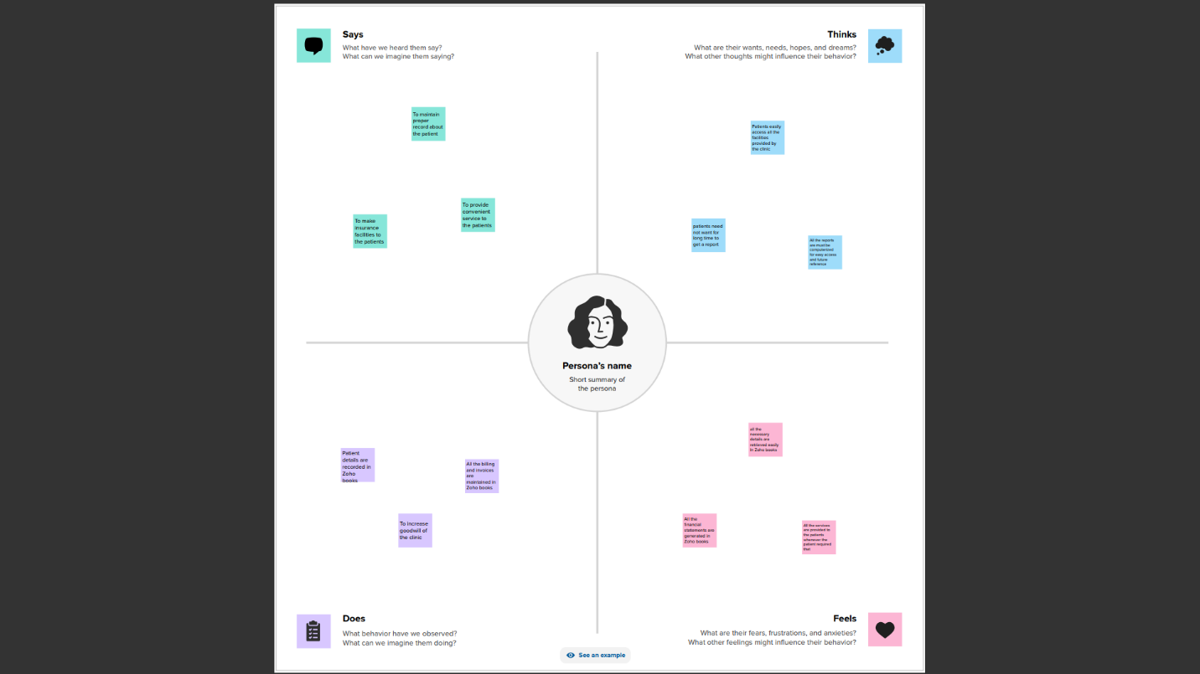

2.2 Ideation & Brainstorming Map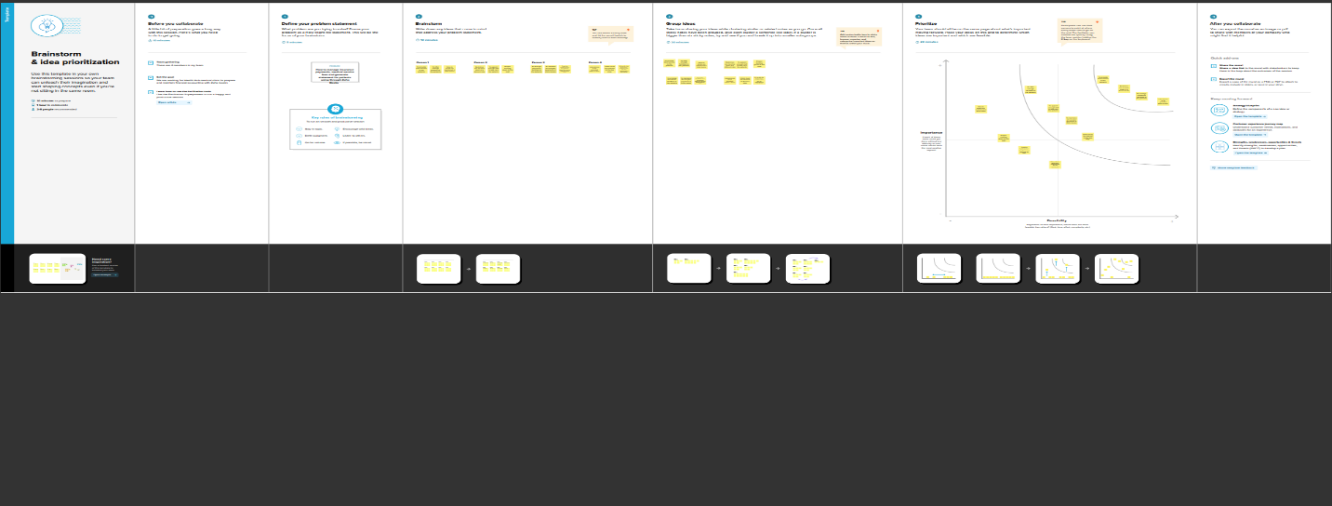

**3. RESULT:**

To Generate the Financial Reports:

1. Profit and Loss Account:

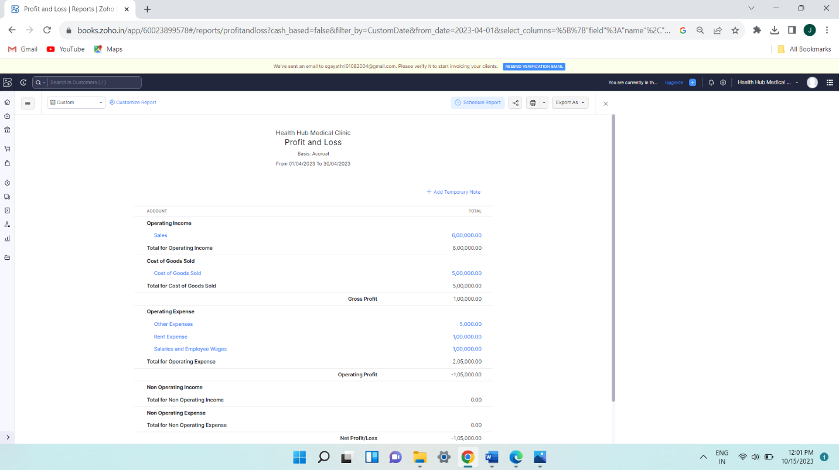

2. Balance Sheet

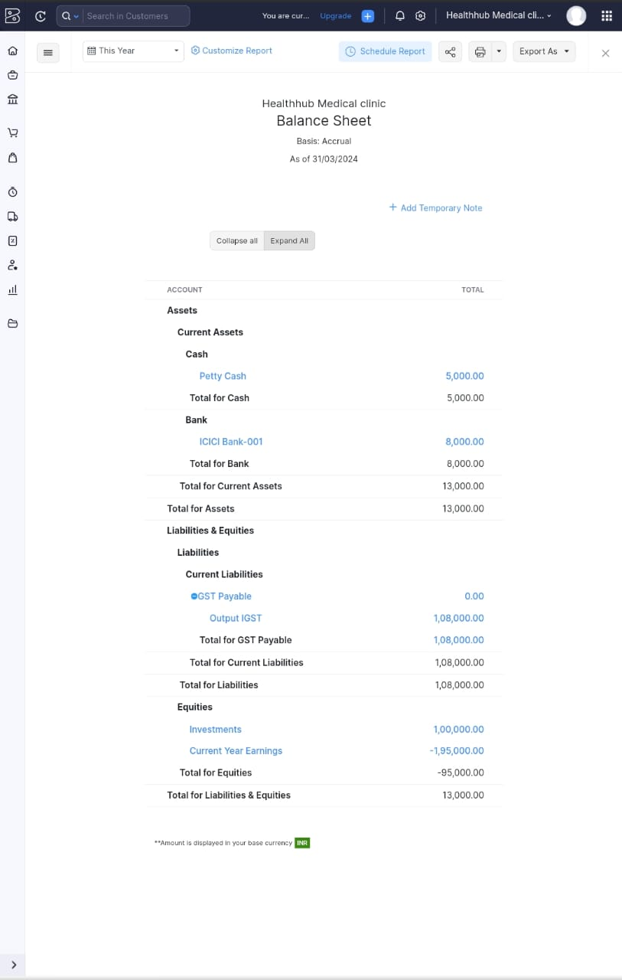.

3. GST Reports

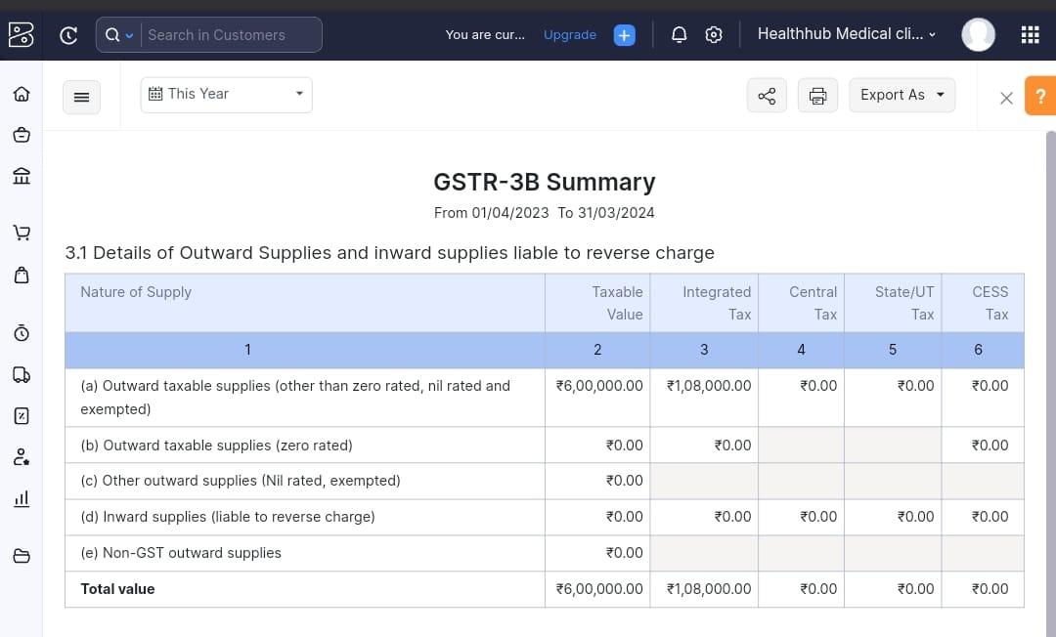

4. Journal Report

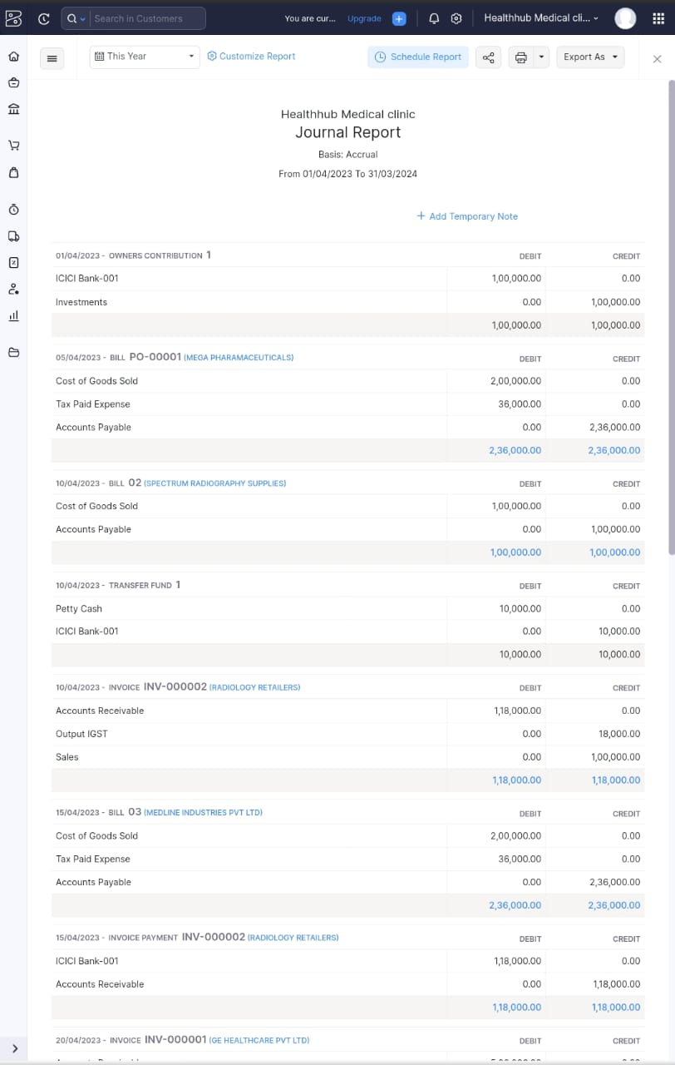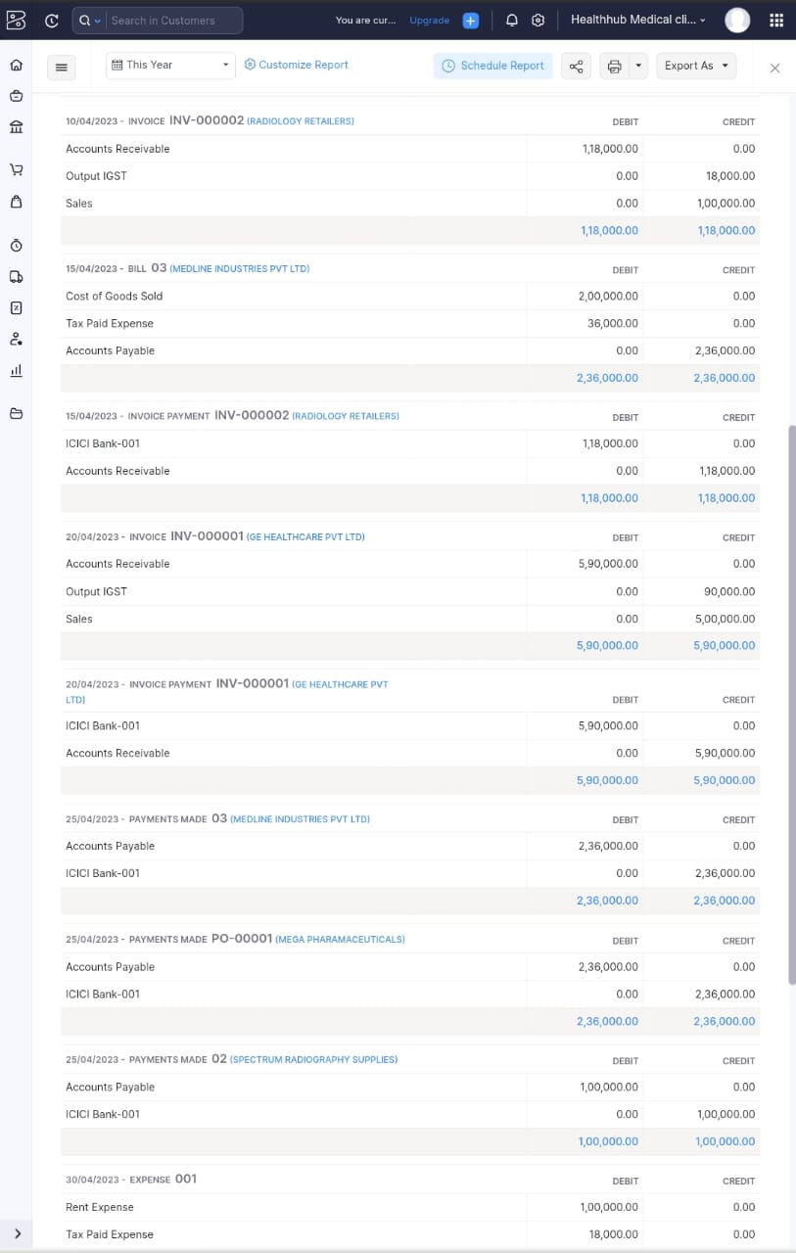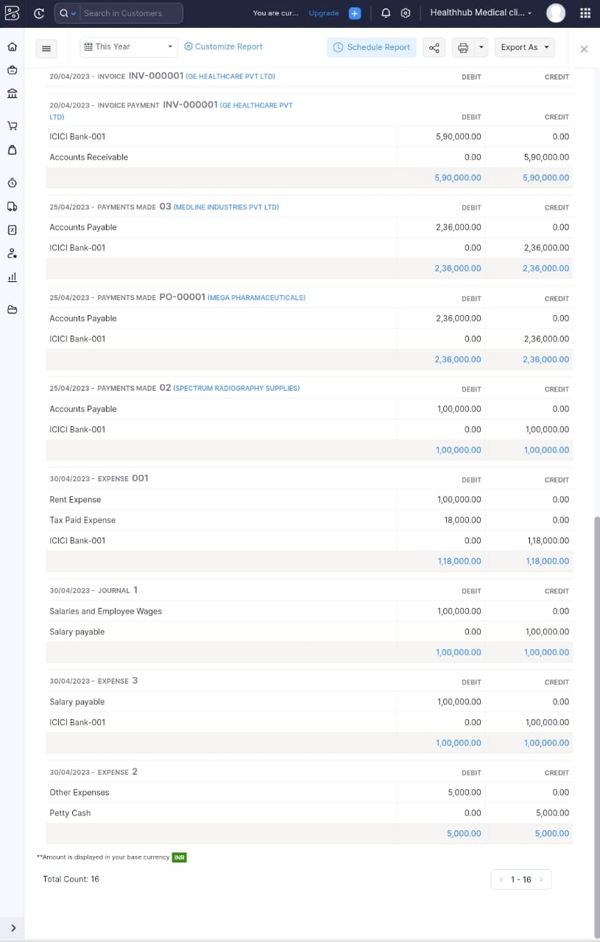

5. Accounts Receivable Summary

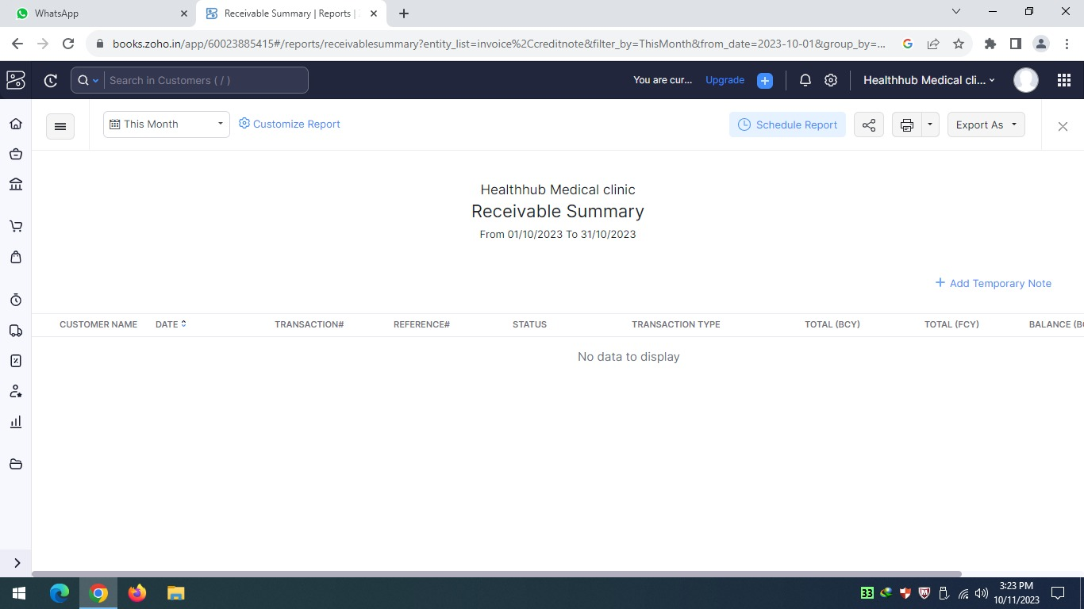

6. Accounts Payable Summary

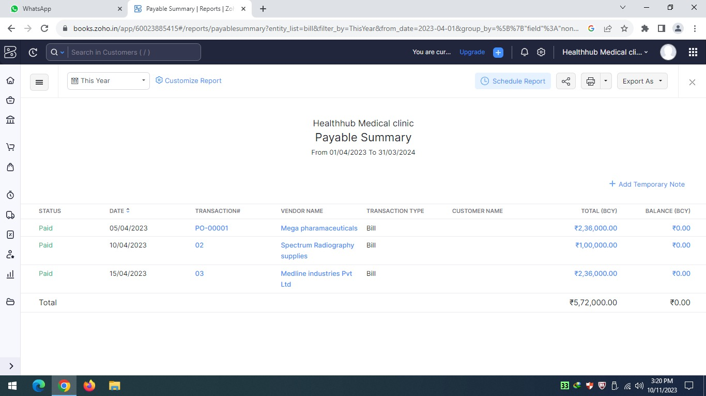

**4. ADVANTAGES & DISADVANTAGES**

List of advantages:

* ZOHO books is cloud based software, so we access the software in any location.
* Creating of Organisation is very easy and user friendly.
* Appearance of software model is very easy to understanding.
* Creation of items, vendors, customers are user friendly while compare with software
* Preparation of purchase order and conversation to purchase Invoice made in a single step.
* Preparation of Sales order and conversation to Sale Invoice made in a single step.
* Default accounting step up is very useful and time saving.
* GST procedure is very easy to enter.
* Getting financial report and tax report in single step.

List of disadvantages:

* ZOHO books is cloud based software, which need internet and other technical facility.
* In absence of internet facility, the working in ZOHO books is very difficult.
* There is no secure in data of the organization.

**5. APPLICATIONS:**

The ZOHO Books is good software in all type of organization and we get better results instantly. We collect the following data and entered in ZOHO Books in various modules like item creation, Vendor creation, customer creation, preparation of Purchase order, Purchase Invoice, sales order, sale Invoice, Making payment to vendors and Expenses, Received amount from Customers.

**Item creation:**

1. General medical consultation Rs.500/- per consultation
2. X-rays scanning Rs.1000/- per scan
3. Preventive health checkup Rs.5000/- per person

Also It purchases the below the list of products for the daily operational use:

1. Pharmaceuticals Rs.1000/- per Box
2. Medical Supplies Rs.2000/-per Box
3. X-ray films Rs.500/- per sheet

Output GST @ 18% is applicable for all the above services and products.

**Vendor creation:**

1. Mega Pharmaceuticals (GST registered)
2. Medline Industries (GST registered)
3. Spectrum Radiography Supplies (Non GST)

**Customer creation:**

1. GE Healthcare (GST Registered)
2. Radiology Retailers (Non GST)

**Preparation of Purchase order, Purchase Invoice:**

1. 05-04-2023 Mega Pharmaceuticals – Pharmaceuticals – Qty 200 boxes @ Rs.1000/-each GST @ 18%
2. 10-04-2023 X-ray films from spectrum radiography supplies – Qty 200
3. 15-04-2023 Medical supplies from Medline Industries – Qty 100

**Preparation of sales order, sale Invoice:**

1. 10/04/2023 Radiology Retailers – X-ray scanns Qty 100 – paid through bank on 20/04/2023
2. 20-04-2023 GE Healthcare – Preventive health checkup for 100 persons

**Making payment to vendors and Expenses:**

1. Employee salaries of total Rs.1,00,000/- paid through bank on 30th April 2023
2. Office rent Rs.1,00,000/- excluding GST @ 18% total invoice value Rs. 1,18,000/- paidthrough bank on same day.
3. Other miscellaneous expenses Rs.5,000/- paid in cash
4. 25-04-2023 paid to mediline industries 2,36,000
5. 25-04-2023 paid to mega pharmaceuticals 2,36,000
6. 25-04-2023 paid to spectrum radiography supplies 1,00,000

**Received amount from Customers:**

1.15-04-2023 Amount received fromRadiology retailers 1,18,000

2. 20-04-2023 Amount received from GE Healthcare pvt ltd 5,90,000

**6. CONCLUSION:**

In maintaining of accounts of Healthhub medical clinic in Zoho books is very smart in all the aspects of entries. The basic accounting concept is enough for the operating person(Accountant/Data entry operator). This software is applicable for all types of organization. The entry models of software are easily understood and interest to work. Whatever reports we need, it’s already default in the report models. Totally it’s a good and very useful to the entire entrepreneur with low cost for operating financial department.

**7. FUTURE SCOPE:**

The idea for the founders of ZOHO Books is amazing and very clever. This is a great milestone in the field of accounts maintenance. They offer various plane as per the requirement of the proprietors. It’s a good gift to all the entrepreneurs.